How to use “Time Tracker for ADO” application

Before you start
To be able to use this application you must get a personal access token from dev.ezure.com.
- Open https://dev.azure.com/Kyndryl/ in your browser and login.
- Click on the Users Settings on the upper right corner.
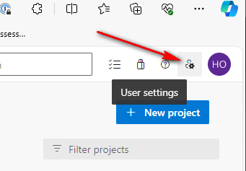
- Click Personel Acces Token item
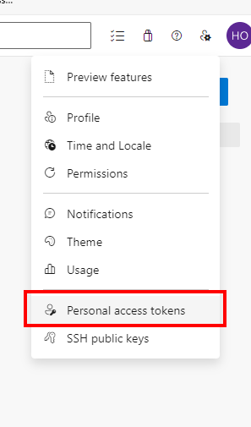
- Click New Token button.
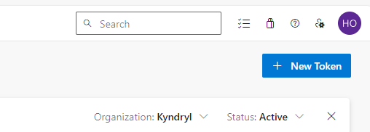
- Enter a Name for the token and select the Expiration period for token. The longer is the better, so you do not need to renew it in short periods. Select the all checkboxes under Work Items section and then click Create button at the bottom of the window..

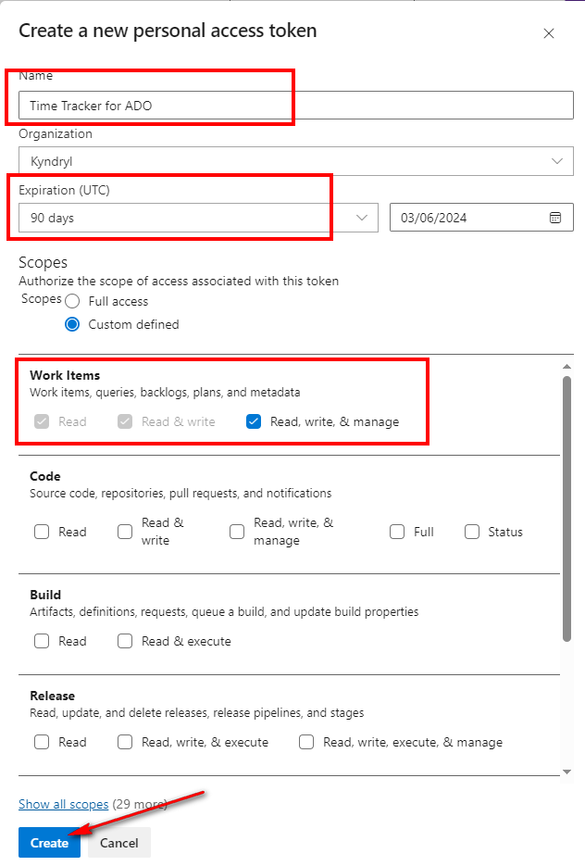
- Make sure you copy the token. Because you will not see it again.
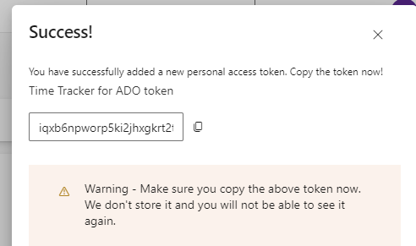

Installation

- Download Timetracker.zip to your computer and extract it.
- Run setup.exe to install it.
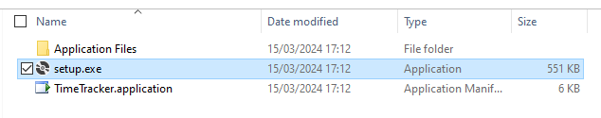
If you get this warning, click More info link and Run anyway button.
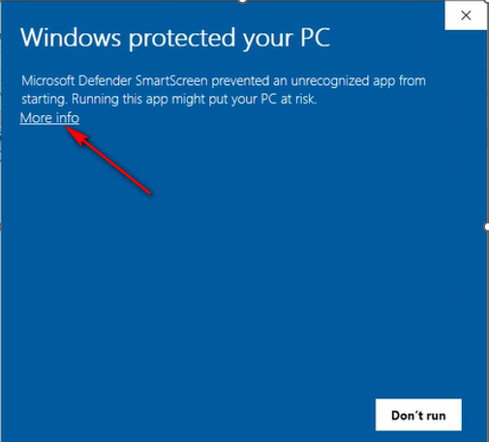
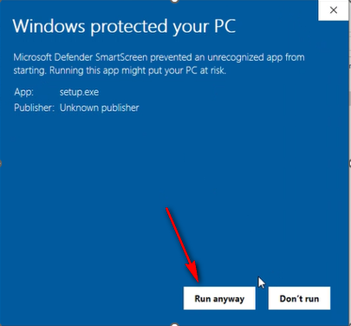
When installation is completed application will be started automatically and you will see the following warning.
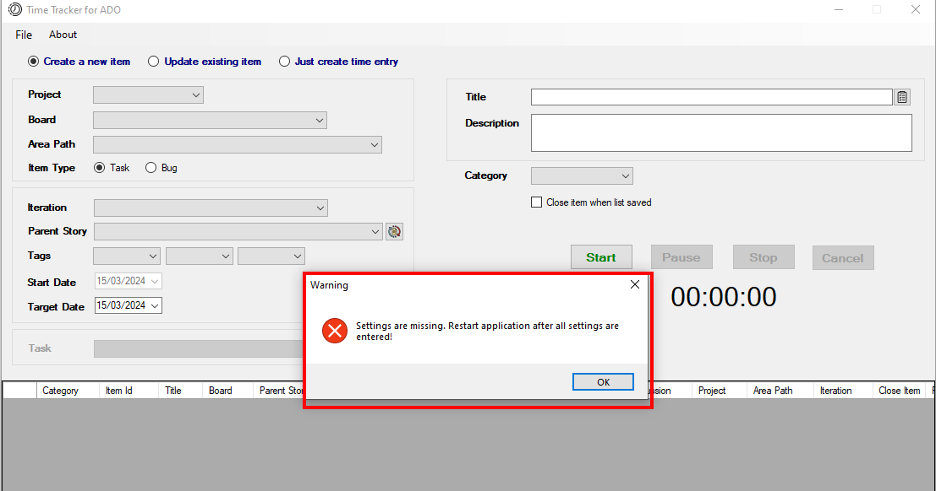
- Click on the file menu and select Settings.
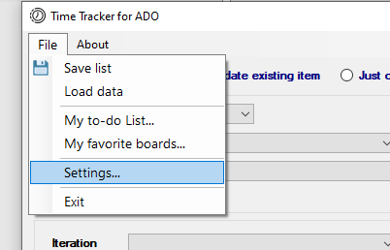
- Fill in the required text boxes.
  - Organization: Kyndryl
  - Organization URL: https://dev.azure.com/Kyndryl
  - Personel access token: <your personel access token>
  - User: <your work email address>
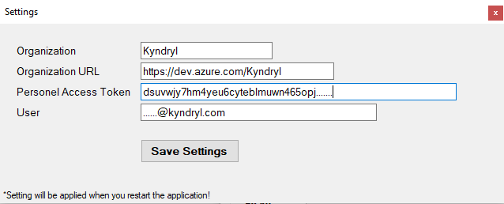
- Save setting and restart the application for the setting to take affect.

How to use
This application can track your time and it can integrate with Azure DevOps. So, you can create/update task or bug in Azure DevOps wtihout using its own environment. There are three different options you can use in this application.
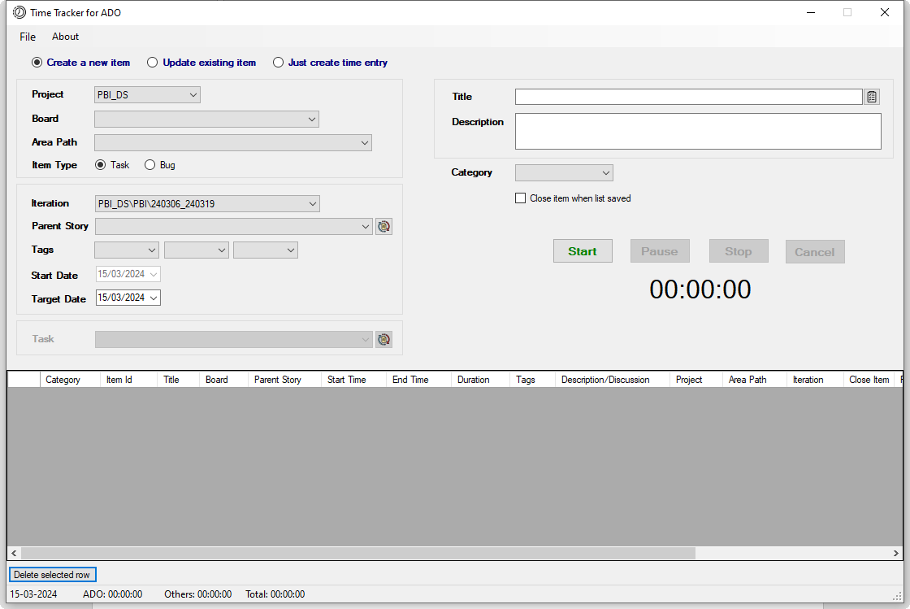

Create New Item
With this option, you can create a task or bug under a selected board and a story.
- Select the board you want to use.
- Select the area path. You can select only the related area path, not others. Area paths may be populated after a 1-2 seconds after you select the board since the app uses async methods for operations.
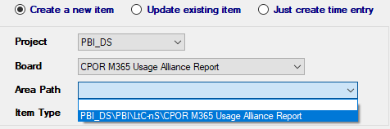

- Item type: Task is selected default. But you can select a bug as well.
- Iteration is automatically selected according to today’s date. But you can select the other iterations.

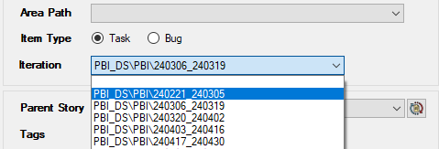

- Select the parent story you want your item to be created under. You can only select stories whose state is active and assigned to you. You must update the stories in Azure DevOps if you want them to be listed here. You can press the little button in red square to refresh the parent story list after updating.

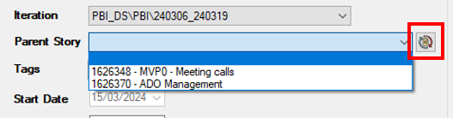

- If there is any tag previously assigned to the parent story, they are automatically selected. But you can change them. These tags will be your new item’ s tag.

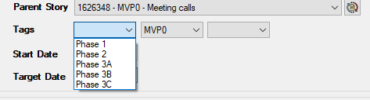

- Start date always shows today’ s date and it cannot be changed. But you can change the target date.

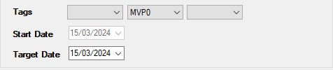
- Enter the title and description for your item.
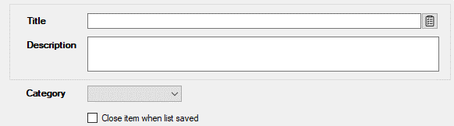

- Category is for reporting purposes only. You can omit it.

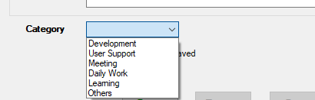

- If you select “Close item when list saved” your item’ s state is set to Close after saving the list.
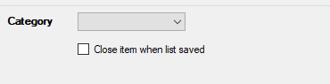

Update Existing Item
With this option you can update an existing task or bug. Update is applied to only target date, iteration path, original estimate, discussion, and the state fields of the item.
Board, Area Path, Item Type and Iteration Paths fields are selected as in Create New Item option. For update option, the following fields are disabled since there are no need to select them. Current date is used as the new target date in ADO item.
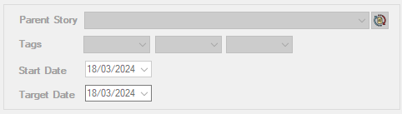

- Select the task to be updated. You can only select task/bug whose state is active and assigned to you. You must update the tasks/bugs in Azure DevOps if you want them to be listed here. You can press the little button in red square to refresh the list after updating.

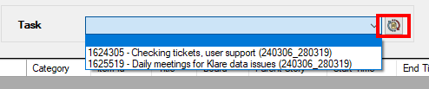

- You can enter your comments in the discussion field. You can also select the checkbox if you want to close the item.

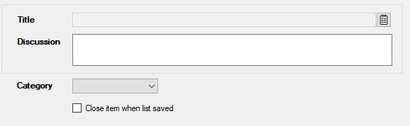

Just create time entry
You can add your non dashboard related things using this option, such as meetings, attending a course etc. The entries created with this option are not sent to ADO.
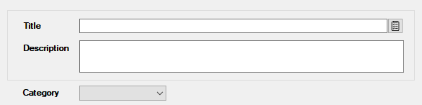

Time Tracking
After selecting the option and filling/selected required field you can start to track your time.
When you press the Start button, timer is enabled, and it starts counting time.
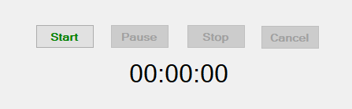
When you press the Pause button, timer is temporarily disabled. You can resume it or stop it.
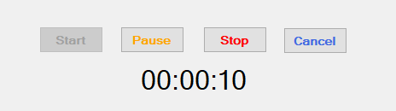
When you stop the timer, it adds a row to the table which contains the fields you selected/entered and start, end time and duration for your entry. If you press Cancel button, it just disables and resets the timer. The fields you selected or entered stay as they are.
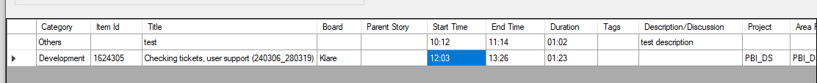
If you double click the start time or end time cells in any row, a small window will popup which you can change the start and end time. When you press the Update button changes are reflected on the table.
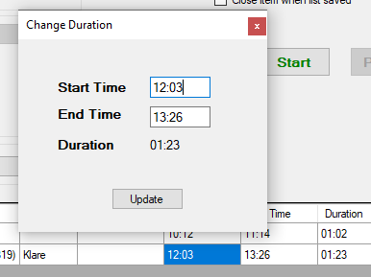

File Menu Items

Save list
You can send your time entries to Azure Devops by pressing the Save List item on the file menu. When you press it, first the whole list is saved to your computer and then line by line sent to Azure to create new ADO items or update existing items. After saving your list you can continue to create new entries. You can save your list any time during the day. Each time only non-saved new entries are sent to Azure DevOps.
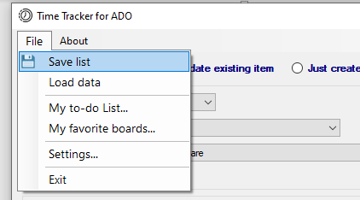

Load data
Whenever you save your list or close the application, entries added to the list are saved to your computer. Application creates a new data file each day. You can view the previously created entries using this option. These files are located in TimeTrackerData folder in your Documents.
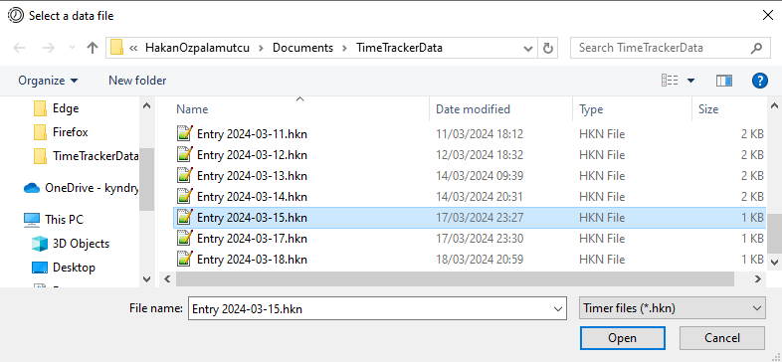
When you load the past data, you cannot change it and you cannot new create time entries for that day. But you can save it if you didn’t before.

My to-do list
This application includes a very simple to-do list not to forget about your other thing to do. You can add a new to-do item by entering a title and description for it and pressing the Add to list button. You can delete the row after selecting it by pressing the button at the bottom left.
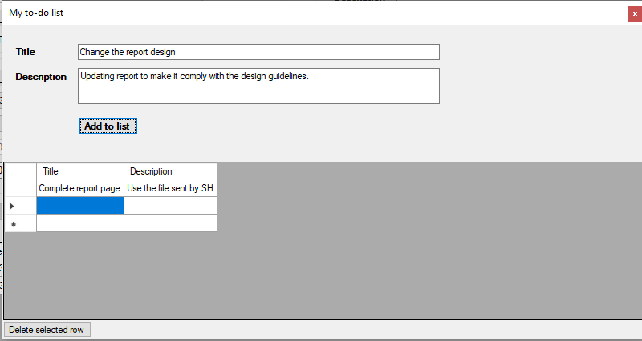
When you press the little button right next to the title text box on the main page, this to-do list window is open. If you double click a row, the title and description is transferred to main screen.
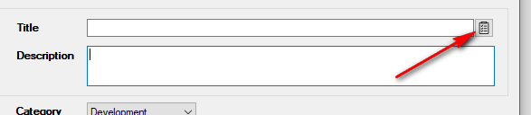

My favorite boards
You can select your favorite board using this option. In the main screen your favorite boards are listed instead of all boards if you select your favorites in this window. You can double click on a board name or click arrow buttons to select and deselect a board.
